**BRD For Distributor Commission Payout Project**

**PROJECT SUMMARY**

PL Asset Management is a leading player in the asset management industry, encompassing both the Portfolio Management Services (PMS) and Alternative Investment Fund (AIF) businesses under its umbrella.

This requirement specifically pertains to the PMS business. The PMS division seeks to automate the commission disbursement process to distributors, partners, and introducer.

The goal is to minimize manual intervention, thereby enhancing data accuracy, reducing operational costs, and increasing overall efficiency.

**PROJECT OVERVIEW**

The current process involves a dedicated executive from the PMS Operations (OPS) team who generates and processes data from the Miles software at the end of each quarter.

This data is used to calculate client-specific fees and generate invoices for distributors/partners and introducer.

The steps involved in the manual process include:

• **Investor Segregation:** Direct investors and distributor investors are separated to apply different fee structures.

• **Fee Type and Distributor Share:** The fee type (management or performance fees) is identified, and the share percentage for each distributor is applied.

• **GST Calculation:** The applicable GST is calculated, and details such as GST certificate number, state code, and NISM certification are retrieved to ensure compliance.

• **AUM and Yield Criteria:** Minimum yield criteria are applied for national distributors, subject to assets under management (AUM) criteria.

**• Data Verification and Validation:** The executive checks for missing or expired data, such as PAN numbers, bank details, NISM certification, and APRN numbers. Payments are held if required documentation is missing or expired.

• **Invoice Generation and Distribution:** Bulk invoices are created using mail merge, converted into PDF format, and emailed to distributors along with an Excel file detailing their investors’ information. The invoices contain essential data like distributor details, fees, GST amounts, and bank information.

**• Payment Release:** Payments are processed once signed invoices are received. The original signed copies are sent to the accounts team, with a copy retained by the PMS OPS team for records.

This project will streamline the invoicing workflow by automating key tasks, such as fee calculation post GST & revenue criteria (Min Yield), and invoice distribution.

It will also improve data accuracy, reduce manual errors, and enhance the overall efficiency of the PMS business’s operations.

REQUIREMENTS OF THE PROJECT HAVE BEEN DIVIDED INTO FOUR DEVELOPMENT STAGES.

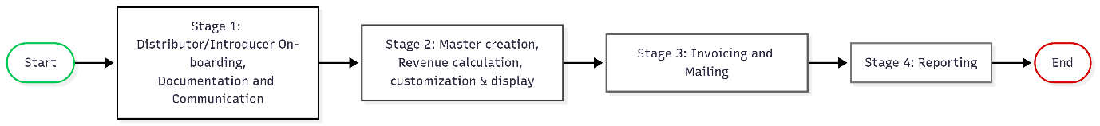

STAGE 1:

DISTRIBUTOR/INTRODUCER ON-BOARDING, DOCUMENTATION, AND COMMUNICATION

**STEPS:**

1) Onboarding Form Completion

The maker fills out the on-boarding form based on the documents received from the distributor/introducer.

Click for [Distributor Onboarding form](https://github.com/AdityaK1197/Distributor-Commisson-Payout-Project/blob/855c367666d4f132045b810e148c13b4c237563c/Distributor_master.xlsx) & [Introducer Onboarding Form](https://github.com/AdityaK1197/Distributor-Commisson-Payout-Project/blob/8a8c445acd41c275b3ebcb4d2360eada1339925b/Introducer_master.xlsx)

2) Document Upload

The system shall provide an upload option for NISM, GST, APRN, and Revenue Sharing pages, along with the option to upload the complete on-boarding form.

3) Approval Workflow

After the maker completes the onboarding, the checker reviews and either approves or rejects the submission with remarks. I n case of rejection, the maker can view the remarks, correct the form, and resubmit.

All approval and rejection activities are logged and made visible to the admin for audit purposes.

|  |  |  |  |
| --- | --- | --- | --- |
| Employee Name | Role | Rights | Designation |
| Nupur Patel | Admin | All | Director |
| Akshay Seksaria | Viewer |  | Head Operations |
| Suraj Dhotre | Checker |  | Team Leader |
| Siddhanti Sawant | Maker |  | Assistant Manager |
| Sunil Bagde | Maker |  | Manager |

4) Welcome Communication

Once approved by the checker, a welcome email is automatically sent to the on-boarding team.

The distributor’s/introducer’s name becomes visible in the distributor list.

For Distributor - Check [mail draft](https://github.com/AdityaK1197/Distributor-Commisson-Payout-Project/blob/18a47fb6b6a1c4dde733aeac95cdcd96512a07b1/Fw_%20PL%20PMS%20Distributor%20Welcome%20Letter.msg) & [welcome letter template](https://github.com/AdityaK1197/Distributor-Commisson-Payout-Project/blob/18a47fb6b6a1c4dde733aeac95cdcd96512a07b1/Distributor%20Welcome%20Letter_BAJAJ%20CAPITAL%20LIMITED.pdf) reference here

For Introducer – [Mail Template](https://github.com/AdityaK1197/Distributor-Commisson-Payout-Project/blob/acc1512865e31b95931a191b4ee2314d3d032aeb/PL%20PMS%20Introducer%20Welcome%20Letter.msg) & [Welcome letter template](https://github.com/AdityaK1197/Distributor-Commisson-Payout-Project/blob/816a127651ab89a5b1482d49383cc4c833312af8/Introducer%20Welcome%20Letter.pdf)

5) Sub-Broker Mapping

If a client is introduced via a sub-broker, mapping can be performed at the client level using the Sub-Broker Mapping tab.

6) Distributor/Introducer Management UI

All on-boarded distributors and introducer are displayed on the UI.

The UI provides edit and download options to make changes or download respective documents as needed.

7) Compliance Tracking and Alerts

Payouts cannot be released to distributors with expired NISM or APRN certifications.

The system will automatically send reminder emails to non-compliant distributors at 30, 15, 7, and 1 day(s) before expiry.

Create a view so the on-boarding team can easily view non-compliant distributors while processing invoices.

8) Automated Communication

All communications are sent to the distributor’s registered email ID.

The assigned Relationship Manager (RM) is included in CC for visibility and accountability.

[Check mail template here](https://github.com/AdityaK1197/Distributor-Commisson-Payout-Project/blob/502f3bffcee2b2a7a8a3d11f3c01ce1def191680/Urgent_%20Renewal%20of%20Expiring%20NISM%20Certification%20Required.msg)

9) Give all documents download option

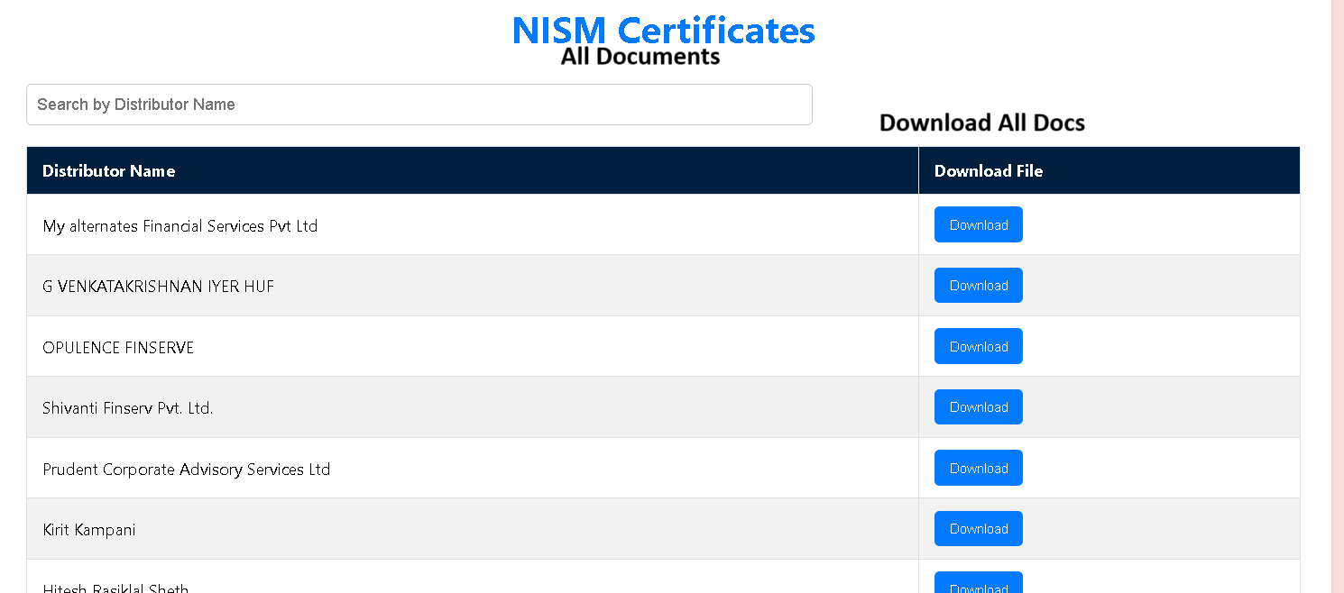

Give toggle/column on screen

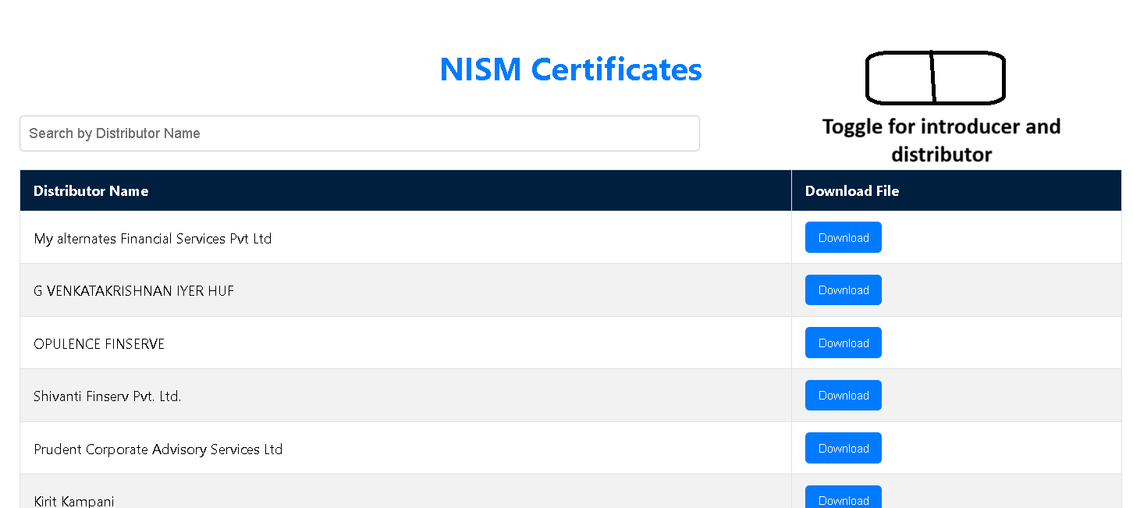

STAGE 2 - MASTER CREATION, REVENUE CALCULATION, CUSTOMIZATION & DISPLAY

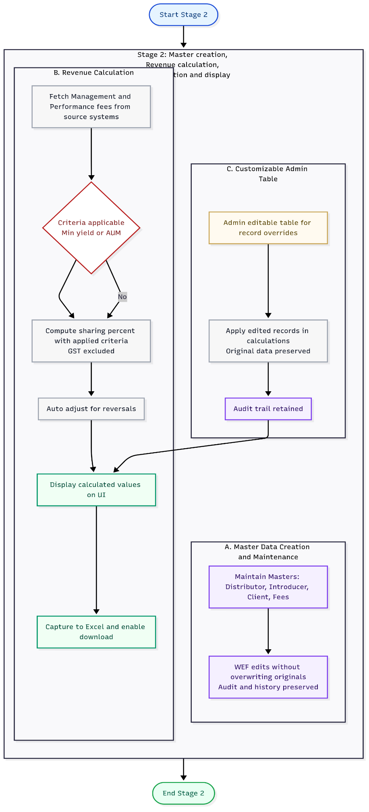

**STEPS**:

A) Master Data Creation and Maintenance

1) Distributor Master, Introducer Master, Client Master, and Fees Master will be maintained within the system.

2) Users can edit records or add data effective from a specific date (W.E.F) without overwriting the original data, ensuring audit ability and historical integrity.

B) Revenue Calculation

1) Management and Performance fees will be fetched from source systems.

2) The system will calculate the distributor/introducer sharing percentage after considering below criteria.

I) Minimum yield criteria (if applicable)

II) AUM criteria (if applicable)

III) Exclusion of GST

All calculated values will be displayed on the UI for verification.

In the event of reversal entries, the system will automatically adjust calculations to reflect updated data.

All data will be captured into excel and would also be available for download.

C) Customizable Admin Table

1) Admin users will have access to a customized editable table where records can be modified.

2) Edited records will be applied for calculations while the original data remains intact, preserving historical accuracy and enabling audit tracking.

3) Remarks added by admin will be captured in respective excels.

Screen for the same is given below

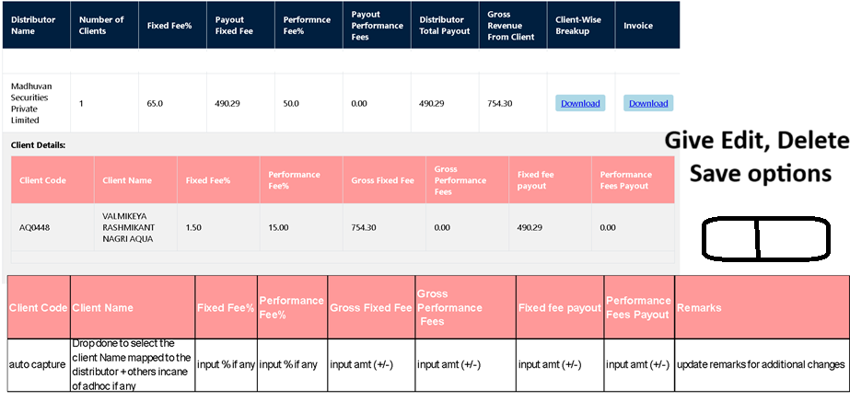

D) Data Freeze

Once data is captured, processed, customized and invoices are released, no changes can be made in historical data.

Bulk upload option for distributor and introducer

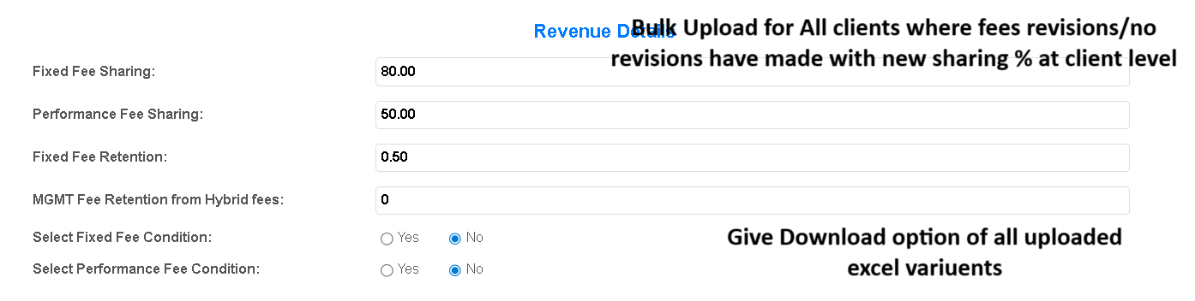

Stage 3 - Invoicing and Mailing – Overview

**STEPS:**

1) Invoice Generation

I) Consolidated revenue for each distributor is calculated and included in the invoice.

II) For distributors registered under GST, 18% GST is applied on the base revenue amount.

2) Client-Level Revenue Details

I)A consolidated Excel sheet at the distributor level, detailing client-wise revenue, is generated.

II) Only distributors with valid NISM and APRN certifications receive invoices and supporting Excel.

3) Automated Email Communication

I) Emails are sent with RM and Servicer in CC, with details fetched directly from the Distributor Master.

II) all emails originate from [pmsdesk@plindia.com](mailto:pmsdesk@plindia.com)

[Find E-mail template here](https://github.com/AdityaK1197/Distributor-Commisson-Payout-Project/blob/7ae943b7a783e6b4eac8377ce065395631ec09b0/Fw_%20Important_%20Quarter%201%20Payout%20Invoice%20from%20PL%20Asset%20Management%20Pvt%20Ltd.msg)

4) Admin Rights and Controls

I) Only Admin users are authorized to send invoices.

II) Admin can use the Send Mail function to:

Include or exclude specific distributors

Send bulk emails to all eligible distributors for the quarter

5) OTP Verification and Delivery Tracking

I) An OTP is sent to Admin along with a list of recipients.

[Draft of E-mail](https://github.com/AdityaK1197/Distributor-Commisson-Payout-Project/blob/80010c2975840bbc7d10f91e6aa27e70ba88c6e5/Fw_%20Verification%20OTP%20for%20Invoice%20Processing.msg)

II) Records that fail compliance checks (e.g., expired NISM) are flagged with remarks.

III) Example:

If 100 distributors are processed, Admin will be informed that 99 received the mail, while 1 failed due to compliance issues.

6) Signed Invoice Management

I) Upon receiving signed invoices from distributors/introducers:

II) Soft copies are uploaded under the Signed Invoices tab

III) Historical signed invoices remain accessible in the system for reference

7) Invoice Forwarding to Accounts Team

Admin can directly forward uploaded invoices to the Accounts Team

[E-mail Draft](https://github.com/AdityaK1197/Distributor-Commisson-Payout-Project/blob/d0a19ddd040a3fddcdea28f9f8ca0dde1923a713/Signed%20Invoice%20of%20%7B%20Distributor%20name%20%7D%20for%20%7BQuarter%20%7D%20%7BFinancial%20Year%7D.msg)

8) Payment Tracking

I) Admin can upload the payment ledger received from the Accounts Team.

II) Alternatively, Admin can mark distributors as paid for the respective quarter.

9) Invoice Submission Reminders

Automated reminders are sent to distributors who haven’t submitted signed invoices, ensuring timely submission and payment release.

[Draft of reminder mail](https://github.com/AdityaK1197/Distributor-Commisson-Payout-Project/blob/fd91e1ff0079535c18706728791f8a992ad80558/Urgent_%20Non%20receipt%20of%20Signed%20Invoice%20for%20%7B%20Quarter%20%7D%20%7B%20Financial%20Year%20%7D.msg)

10) Log file will be saved for all the activities and will be visible to admin only.

11) Invoices before 1 Jan 2025 will be generated on old invoice format of PLPL.

[Find Old invoice format](https://github.com/AdityaK1197/Distributor-Commisson-Payout-Project/blob/8c3ba781d25e91e71e6a6bb190f59466e12b3885/Real%20value%20enterprises%20private%20limited%20Q3%20fy2425.pdf)

12) Invoice format for introducer

I) [With GST](https://github.com/AdityaK1197/Distributor-Commisson-Payout-Project/blob/52488fc18314d78f1e840c62fb074d576fa05777/Introducer%20Invoice%20with%20GST.docx)

II) [Without GST](https://github.com/AdityaK1197/Distributor-Commisson-Payout-Project/blob/52488fc18314d78f1e840c62fb074d576fa05777/Introducer%20Invoice%20without%20GST.docx)

Stage 4: Reporting – Overview

Report Types:

1)Custom Distributor Master Report - [Format](https://github.com/AdityaK1197/Distributor-Commisson-Payout-Project/blob/d8d97267db0d2735cf94b5106e9a8fb4e5dc5d25/Custom%20Distributor%20Master%20Report.xlsx)

This report will include all data related to distributors, including custom fee mappings and the W.E.F (With Effect From) option.

Access will be restricted based on user roles.

2) Customer Introducer Master Report - [Format](https://github.com/AdityaK1197/Distributor-Commisson-Payout-Project/blob/4b501b1f30ae64f54a3406491f52f6001190c6f4/Customer%20Introducer%20Master%20Report.xlsx)

This report will contain comprehensive data related to introducers, providing insights into their associated clients and revenue.

3)Custom Client Master Report - [Format](https://github.com/AdityaK1197/Distributor-Commisson-Payout-Project/blob/b03e4babd25cffc72d5593f6dd9aabf87a46d711/Custom%20Client%20Master%20Report.xlsx)

This report will include all data pertaining to clients, active/closed status, fee details, and business source.

~~4)Custom Fees Master Report -~~ [~~Format~~](https://github.com/AdityaK1197/Distributor-Commisson-Payout-Project/blob/0dc8b8a2226c8d44571e4a6c9234a2a4d94ed52b/Custom%20Fees%20Master%20Report.xlsx)

~~A detailed report showing fee structures with W.E.F dates, including any custom fees applicable to clients.~~

5) Invoice Master Report - [Format](https://github.com/AdityaK1197/Distributor-Commisson-Payout-Project/blob/dfd8fa0170288a2a708134d13b9ba3dcbc4d8144/signed_invoices%20(1).xlsx)

This report will provide a summary of all invoices uploaded by the Admin, including their status and associated details.

6) Sub-Broker Master Report

This report will include all details of sub-brokers mapped to distributors, offering visibility into their business relationships and performance.

[Click here for format](https://github.com/AdityaK1197/Distributor-Commisson-Payout-Project/blob/2e8412a67dcc758b54a807baafbaa77abe776264/subbroker_mapping.xlsx)

7) Client-wise Breakup (ZIP Format)

A ZIP file containing client-wise Excel sheets, detailing their respective business transactions and revenue breakdown.

[Click here for format](https://github.com/AdityaK1197/Distributor-Commisson-Payout-Project/blob/36280dbb2462d42680b99064a831d9a19d55d9be/Client_wise_breakup%20(12).zip)

8) All Distributors Invoice ZIP

A ZIP file containing all invoices generated for distributors, facilitating bulk access and review.

[Click here for format](https://github.com/AdityaK1197/Distributor-Commisson-Payout-Project/blob/36280dbb2462d42680b99064a831d9a19d55d9be/all_distributor_invoices%20(9).zip)

9) All Client Report along with consolidated distributor commission report.

[Click here for format](https://github.com/AdityaK1197/Distributor-Commisson-Payout-Project/blob/10e8d534e6fd117f1e6ad4a227e62632804c742a/Final_Comprehensive_Client_Report_2025-2026_Q1.xlsx)

10) A Master Working report where Admin can view the consolidated data of all clients, including those from Direct, Distributor, Introducer, and Sub-Broker business sources.

[Check format here](https://github.com/AdityaK1197/Distributor-Commisson-Payout-Project/blob/88fce1ef3c7729a30bf6c5022b4c8d63ef9cc489/System_Comprehensive_Client_Report_2025-2026_Q1%20(21).xlsx)